Project Plan

Victoria State Accident

Danny Thai (s5230918)

Sean Karl Angelo Enarbia (s5228570)

Table of Contents

1.0 Introduction 3

1.1 Problem Background 3

1.2 Scope 3

1.3 Document contents 3

2.0 Work Breakdown Structure 4

3.0 Activity Definition & Estimation 5

4.0 Gantt Chart 6

# Introduction

## Background

The Victoria State Accident shows road crash statistics for the last five years from 2015 - 2020 for the state of Australia/New Zealand. All fatal crashes and injuries have been recorded during the last 5 years in reporting period. The data on the site shows the analysis of Victorian fatal and injuries data based on time, location, crash types, road type users, object hit, etc. This dataset relates to different types of crashes or injuries of the people during this period. The dataset also includes the alcohol accident referring to different alcohol type accidents and provides the impact on alcohol or any other type of fatal accidents.

## Scope

**Project Scope:** In this project, we are to provide a project plan that is referred to as the Victorian State Accident Dataset. We are to use the information and data to answer and complete various tasks that have been provided to us. This includes creating a WBS structure to overview how our team is completing tasks each week along with the Gantt chart to estimate how long it takes to complete. Another part is to provide a software design document that is related to the Victorian State Accident. This part is implementing the database for the Victorian Accident, and we are to create a software app for the users who will be using this can find information based on the Victorian Accident that occurred five years ago.

**Project Scope Management:** We are to work together by completing tasks each week that has been provided to us. We are to complete the tasks each week and record the time it took to complete each week. We are also to deliver a product such as documents of the project plan and the overview of the software document to design what the software system is going to be. The software is also going to have functions implemented so that the users who are interacting will not have a hard time understanding the main functions of the system’s components.

**Deliverable:** The following are to be delivered to the client:

* Project Plan
* Software document
* Gantt Chart
* Software Testing Report
* Wireframes
* Work Breakdown Structure (WBS)
* Executive Summary

## Document contents

In this document, the contents included are a project plan that includes a Project Overview which will be included at the end, Work-Breakdown Structure, Activity Definition and estimation and a Gantt chart for displaying scheduling & time estimation. The project plan should include sensible estimates for the various tasks required for both Part A and B tasks. As each task's variants components are completed, it is to be recorded in the completion time/dates of the Gantt chart to track how close each time complete estimates on each task.

Another part is to prepare a Software Design Document for one of the data sets which is the Victorian State Accident Dataset and provide some related questions according to the dataset. This includes a System Vision Statement. It also shows produces a formal list of requirements that need to be satisfied such as use cases for the software, a listing of system components and the related software design, and an early user interface design/wireframe implementing how users are going to use this piece of software.

# Work Breakdown Structure

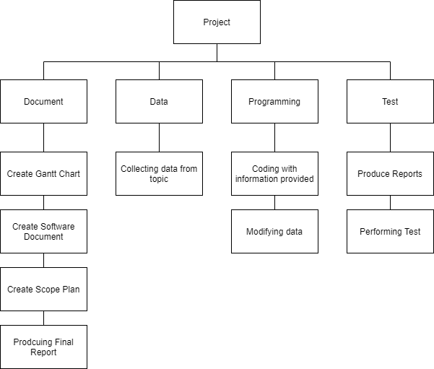

# Activity Definition & Estimation

* 1. **Document:** We are to prepare a document for the software system we are importing about the Victorian State Accident. There are two documents that would be the Project Plan and the Software document implementing the plans and information about the software system.
  2. **Create Gantt Chart:** We are to create a Gantt Chart according to the Work Breakdown Structure which makes it a bit easy when creating the chart. This would also include the estimated time which is not being calculated yet.
  3. **Create Software Document:** We are to fill out the document which has the template for each section of the software system. This is the planning stage for the final product of the software system for the dataset of the Victorian State Accident.
  4. **Create Scope Plan:** This is total the amount of work that the team members are to complete to deliver the product which would be the documents for the project plan, software document and any other documents that are related along with the estimated times that takes how long to complete.
  5. **Final Report:** For the final report, this is the finishing software system of the Victorian State Accident, this provides the final report on the software system that has been completed and we are to write an executive summary based on the whole process of this assessment.

1. **Data:** We are to research and analyse the dataset of the Victorian State Accidents that occurred five years ago.
   1. **Collecting Data:** We are importing the dataset of the Victorian Accident into the software system for the users to collect some data about each accident.
2. **Programming:** We are to add some functions to the software system and the components for the dataset to function properly when interacting with it.
   1. **Coding:** We are to import some python codes to connect the dataset to the software system to make it function properly and steadily.
   2. **Modifying the data:** If we find more interesting data, then we would update it into the dataset such as excel before implementing it into the software system.
3. **Test:** We are to test the software system before handing it to the client. By doing this, we can spot any error within the system if the data is not set and functioning properly as we expect it to do when the users are interacting with it. We can also make some changes to the code if necessary.
   1. **Produce Reports:** We are to produce a report about the test each time we do so we can analyse the data of the software system and identify the problem within.
   2. **Perform Testing:** We are to test the software system when it successfully implements the dataset of the Victorian State. We are to perform each test such as searching, coding and importing each time into the system.

# Gantt Chart

